From: http://davidstockmanscontracorner.com/economic-war-the-donald-goes-full-retard/

Economic War! The Donald Goes Full Retard, Part 1
By David Stockman. Posted On Monday, August 6th, 2018
August 5, 2018 might well be marked as the date that America's impending political and economic crisis passed the point on no return. In a tweet storm on that muggy August sabbath, the Donald finally went full retard with his lunatic Trade War.
Indeed, not since Huey Long has an American politician--let alone one domiciled in the Oval Office---emitted such incoherent economic babble as the Donald's rant on his trade maneuvers:
Tariffs are working far better than anyone ever anticipated. China market has dropped 27% in last 4 months, and they are talking to us. Our market is stronger than ever, and will go up dramatically when these horrible Trade Deals are successfully renegotiated. America First.......
Every country on Earth wants to take wealth out of the US, always to our detriment. I say, as they come, tax them. If they don’t want to be taxed, let them make or build the product in the US. In either event, it means jobs and great wealth.
Because of tariffs we will be able to start paying down large amounts of the US $21 trillion in debt that has been accumulated, much by the Obama administration, while at the same time reducing taxes for our people.
Let's cut to the chase. There is not an iota of linkage to real world facts, logic or analysis in this entire rant; it's just truculent juvenile defiance issuing from the fat fingers of an economic ignoramus.
So be warned. The Donald's madcap mind-melt on trade and economic warfare against global malefactors of his capricious choosing is surely the catalyst that will bring down the whole house of cards. That is,
- the egregious Wall Street bubbles,
- America's aging, limpid economic recovery and
- Imperial Washington's monumental Fiscal Debauch.
And that's especially the case when you throw on top of the Donald's Trade War another economic war in the form of sanctions on Iran---followed by a derivative economic war on Europe, China, India, Turkey and others for daring to trade with a Washington proscribed malefactor.
That is, beginning tomorrow it will be illegal to buy Persian carpets or pistachios from Iran; trade with it in such items as graphite, coal, aluminum, steel, software, gold, automotive products etc; engage in financial transactions involving Iran's currency or payments through its central bank; or, after November 5, buy Iranian oil or engage in commerce with its ports, shipping and ship-building sectors.
Needless to say, since Iran has not violated any part of the JCPOA nuke deal, most of the world doesn't cotton to the Donald's bluster and unilateral reactivation of sanctions.
Thus, China has refused to cut its oil import and in fact ramped up purchases by 26% in July when it single-handedly accounted for 35% of Iran's oil exports. While it has promised not to raise its purchases after oil sanctions become effective on November 5, China's rope-a-dope maneuver is obvious: it's playing the old game of inflating its compliance base prior to the effective date freeze, thereby providing an interim diversion bridge to absorb the now falling purchases by South Korea, Japan and lesser Asian fry.
Likewise, the EU has activated it own "blockage" law. The latter bans European companies from complying with US sanctions, gives them the right of recovery in European courts and declares null any US court proceedings seeking to impose penalties on EU companies.
Stated differently, Washington has declared yet another foreign war, but this time Europe firmly declined the invitation to join, as it formally announced this AM:
We are determined to protect European economic operators engaged in legitimate business with Iran, in accordance with EU law and with UN Security Council resolution 2231. This is why the European Union’s updated Blocking Statute enters into force on 7 August to protect EU companies doing legitimate business with Iran from the impact of US extra-territorial sanctions.
Not surprisingly, the EU's declination of this opportunity to shoot its struggling economies in the foot only opened up another venue for Trumpian attack. If the Swedes dare buy a bag of pistachios or the Italians a barrel of oil from Iran, the Donald's wrath shall be brought to bear upon them with all deliberate force:
The Trump Administration intends to fully enforce the sanctions reimposed against Iran, and those who fail to wind down activities with Iran risk severe consequences."
This gets us to the meat of the matter. Owing to the phony economic surge and the relentless stock market bubble, the Donald has now become completely unhinged and un-chaperoned. There is no one left in the White House to advise him except for fanboys (Kudlow), sycophants (Mnuchin), fanatics (Navarro), war-mongers (Pompeo and Bolton), beltway racketeers (Lighthizer) and the walking dead (Wilbur Ross).
Accordingly, Trump is flying by the seat of his pants with absolutely no base of experience or knowledge to constrain his increasingly impulsive and bombastic utterances. For instance, he's being told by Bolton that Iran is already on its knees---when the truth is more nearly the opposite.
This time the sanctions will leak like a sieve because virtually the whole world is opposed to Trump's renewed sanctions---meaning that "enforcement" actions will produce as much skirmishing with China, India, Turkey, the EU etc. as it inflicts hardships on the relatively insular economy of Iran.
In fact, aside from $55 billion of oil, plastics and other petroleum derivative exports in 2017, Iran's other exports totaled a miniscule $8 billion. That's just 1.8% of its $450 billion GDP, meaning that the Donald's unilateral sanctions will be leaky as all get out on oil, a non-issue for the rest of its production sectors and a moderate burden on everyday Iranians who will face surging prices for imported consumer goods and pharmaceuticals.
Still, that's nothing close to an economic body-blow----just enough pain for the regime to rally the nation's long-suffering public once more against the Great Bully in Washington. Meanwhile, the Donald is charging forward on the false premise that Rouhani will soon be begging for relief:
Iran, and it’s economy, is going very bad, and fast! I will meet, or not meet, it doesn’t matter - it is up to them!
The point is that world trade will be an ungodly mess by November. We have no doubt that Trump will move to the next round of tariffs on $200 billion of Chinese imports; that the Iranian sanctions will be ricocheting through global trade; and that there will be no deals on NAFTA or with the EC per the platitudinous outcome of the [EU's] Juncker head-fake during his recent White House confab with the Donald.
Moreover, a 25% levy on the next round of China tariffs will not only smack the US economy with upwards of $50 billion of added costs, but it's also virtually certain to drastically stiffen China's resolve. As today's official communique through the People's Daily made clear, Beijing has finally realized that the Donald is completely unhinged on the trade matter and that the usual promises to buy more of what they were going to buy anyway won't cut it with Trump.
So they are digging in for a real Trade War. And the recent 10% swoon of the yuan against the dollar makes clear they are prepared to take considerable risks in terms of potential capital flight and domestic inflation to go toe-to-toe with the Donald:
......But China will never surrender to blackmail and will definitely rise to defend itself when it involves national interests and national dignity.....China has to defend its right to development, and we don't fear sacrificing short-term interests. However, the US will bear losses as well. It's a mutual depletion where people in both countries have to pay the same price.
Throughout history, the US arrogantly initiated many wars that eventually ended up hurting itself. Washington's arrogance this time is up against a major power. When others believed that the US was just playing tricks with trade, the White House thought it could strike down China. But the US' ability doesn't match its ambition.
China has time to fight to the end. Time will prove that the US eventually makes a fool of itself.
In this context, the fragility of the financial, economic and political foundations of America can not be exaggerated. The stock market is so absurdly over-valued that only a few more weeks of the trade and sanctions madness now in full gallop has the potential to catalyze an unexpected tumultuous sell-off.
If it does, it will be Katy-bar-the-door time because the Fed is absolutely resolute about monetary normalization and draining the bond pits at a $600 billion rate---even as the Fiscal Debauch enacted with last winter's tax cuts and spending spree hits the budget accounts with full force.
During the last three months, the fiscal handwriting on the wall as become absolutely clear. Payroll withholding receipts are down by nearly 5% and total revenue are off by 7% owing to the complete collapse of corporate income tax receipts.
We will have more detail regarding the rapidly collapsing fiscal front in Part 2, but as to the macro-economic implications of the Donald's economic war against the world, history is both clear and entirely ignored.
When a business cycle gets long in the tooth under today's regime of central bank driven Bubble Finance, the fact that quarterly GDP prints remain positive--even "strongly" so---doesn't mean that anything like blue skies lie endlessly ahead.
During the 12 quarters before the inception of the Great Recession, for instance, there occurred a 5% and a 4% "growth" quarter and a total of four quarters above 3%. Altogether, real GDP growth averaged 2.5% over the period.
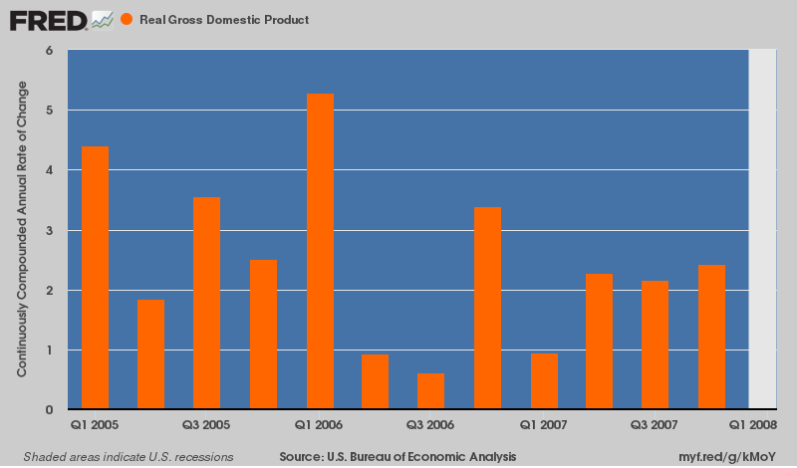
Likewise, during the run-up to the dotcom crash in the spring of 2000, the "no recession in sight" mantra was even more compelling. During the previous 12 quarters, real GDP growth grew by more than 6% at annualized rates during three quarterly prints and by more than 3% in 11 quarters---with growth averaging 4.6% per annum over the period.
By contrast, not withstanding the storm damage repair bulge in Q4 2017 and tax cut consumer spend-a-thin and export pull-forward aberrations of Q2 2018, the current 12 quarter average is just 2.1%.
Stated differently, it will only take a feather to blow over the US economy, but once the Wall Street selling starts it will be blunderbuss of restructuring layoffs, facility closures and write-offs that emerges from the panicked C-suites.
Needless to say, Donald Trump does not have a clue that he's living in a financial and economic glass house---so his tossing boulders with reckless abandon.
And he also has no clue that the Imperial City---and especially its establishment Republican wing---has not acquiesced to his inconvenient mayhem.
Washington is just waiting for the wheels to come off the stock market's wagon. Then the gloves will come off for real, and the Donald will eventually find himself tweeting from the Dick Nixon Memorial Helicopter.

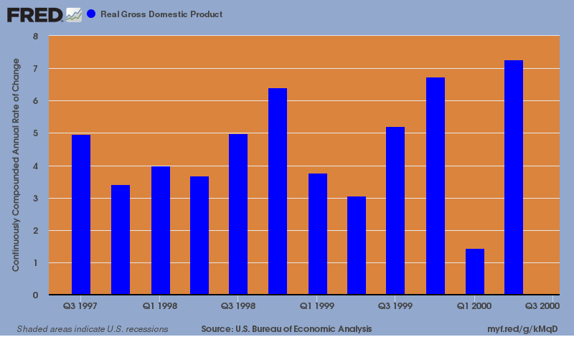
In the interim, today's shocking announcement from Newell will become ever more frequent---eventually causing even the insouciant boys and girls still romping in the casino to bee-line for the exits. Upon warning that the annualized impact of the Trumpian tariffs could amount to a $100 billion profits hit, the company promptly shed nearly 15% of its market cap.
And there's a lot more from where this came from:
The company, which has a wide range of consumer brands including Sharpie, Graco, Mr. Coffee, Paper Mate, Rubbermaid and Yankee Candle, reported before Monday’s opening bell that second-quarter net income declined to $131.7 million, or 27 cents a share, from $223.0 million, or 46 cents a share, in the same period a year ago.
Chief Executive Michael Polk said a key factor that could impact second-half results is the new U.S. tariffs on China sourced goods, and the retaliatory tariffs imposed by the European Union and Canada in response to U.S. tariffs on steel and aluminum imports.Polk said as the tariffs currently stand, the annualized impact on results could be as much as $100 million.

